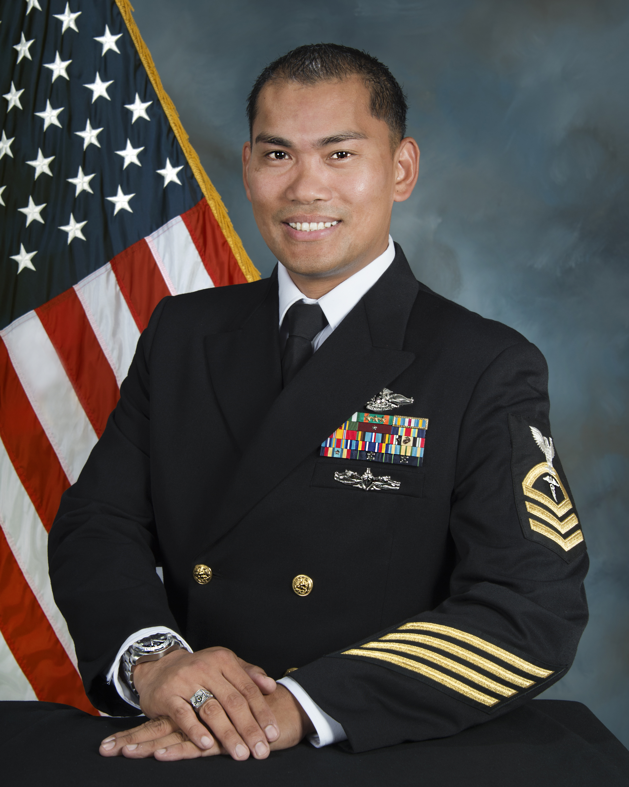
HMC(FMF/SW/IDW) ARNEL U. CARBONELL
UNITED STATES NAVY

Chief Carbonell was born in Manila, Philippines and grew up in Las Vegas, NV. In July 22, 1998 he enlisted into the United States Navy and attended Recruit Training Great Lakes, IL.

Following completion of Hospital Corpsman “A” School in Great Lakes and Field Medical Service School in Camp Pendleton, CA, he was assigned to Bravo Company, 1st Medical Battalion, 1st Force Service Support Group where he worked as a general duty Hospital Corpsman. He was later assigned to 11th Marine Expeditionary Unit where he completed one Western Pacific Deployment onboard the USS Harpers Ferry (LSD-49). During this tour, he was promoted to Third Class Petty Officer, received the Fleet Marine Force ribbon, Enlisted Surface Warfare Specialist, and Enlisted Fleet Marine Force Warfare Specialist.

In 2002, he reported to Naval Hospital Bremerton, WA and served as the Leading Petty Officer of Ambulatory Procedure Unit and Anesthesia. During this tour, he deployed with Fleet Hospital Eight in support of Operation Iraqi/Enduring Freedom.

In 2006, he reported to 3D Medical Battalion, Camp Hansen, Okinawa, Japan where he excelled as the Battalion Educational Services Officer and Assistant Leading Petty Officer of Adjutant Office. During this tour, he was advanced to First Class Petty Officer and participated in numerous exercises.

Following a one year tour in Okinawa, he reported to I Marine Expeditionary Force Camp Pendleton, CA in 2007 and served as the Leading Petty Officer of 16 Area Consolidated Aid Station. During this tour, he was forward deployed in combat operations in support of Operation Iraqi Freedom, Camp Fallujah.

In 2009, he was advanced to Chief Petty Officer while in transit to Center for Security Forces Detachment (SERE SCHOOL) North Island, CA. and held various positions as Leading Chief Petty Officer, Training Safety Officer and Command Fitness Leader. During this tour, he deployed Individual Augmentee to a joint service environment in Isa Air Base, Bahrain, earned his Master Training Specialist and Enlisted Information Dominance Warfare Specialist.

In 2013, Chief Carbonell returns to Okinawa, Japan and reported to Combat Logistics Regiment 3 and served as the Senior Enlisted Leader and Plans, Operations and Medical Intelligence Officer. While onboard, he deployed to Philippines in support of Humanitarian Assistance and Disaster Relief Operation Damayan and various training exercises.

In August 2015, he assumed the duty as Senior Enlisted Leader of Naval Medical Administrative Unit Monterey, CA.

His personal awards and decorations include the Navy and Marine Corps Commendation Medal, Navy and Marine Corps Achievement Medal, and various campaign and service medals.

Chief Carbonell is blessed with son Skyler Jai.

