Advance Design
DA 4500

Spring 2016

Syllabus

Professor: Dr. Harold Nelson hgnelson@nps.edu (preferred)
Telephone: 206.795.0700 (cell) nelsongroup@cal.berkeley.edu

Course Materials & Resources

Supplemental materials and resources are assigned & posted on:
Sakai Collaborate: AD4500 Spring Quarter class site.

- Purpose of Course: The Development of Design Expertise

The purpose of this course is to support you in your professional evolution as a design expert by focusing on the development of your design expertise—the ability to create desired change in organizations or situations.

Design expertise is applicable to every domain of human activity including military organizations, governmental agencies, social institutions, businesses and personal endeavors. Design is an across-the-board approach that can be adapted to particular situations and specialized fields or disciplines of every kind. The challenges and experiences of a military or governmental organization or an individual are often unique to context specific settings, requiring specialized skills and strategies. However, given the challenges of the modern world, there is a critical need for a seminal, strategic approach linking proactive inquiry to action—i.e. advanced design. This requires the acquisition of design expertise—the focus of this course.

Design expertise is inclusive of routine expertise and adaptive expertise but is a more proactively intentional strategy than either of them.

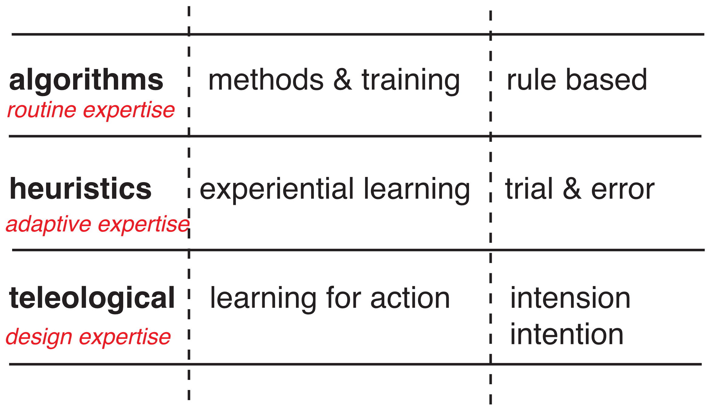
expertise

Course Themes: Designers, Designing, and Designs

The course follows three threads of inquiry: 1) designers, 2) designing, 3) designs. The threads are not picked up sequentially but are woven into a holistic understanding of advanced design.

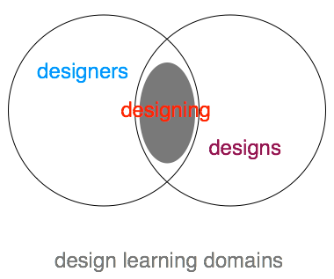

themes

- Course Structure: Preparation, Application, Practice

This course is structured dynamically around three sequential phases of professional development in design expertise. The three phases include: 1) preparation, 2) application, 3) practice. The phases are initiated sequentially but continue to develop in parallel throughout the course.

- Course Focus: Domains of Study

This course focuses primarily on the professional domains of capacitation, inquiry and praxis. The domain of character development is supported in the course but remains your primary responsibility as a course participant.

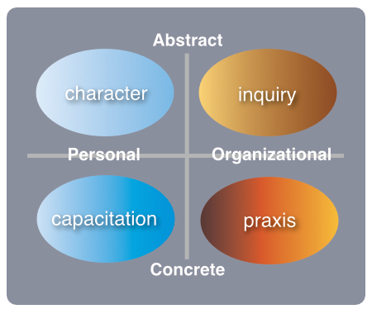
domains of professional development

- Praxis

A set schema is used as an organizing strategy for your professional development as an advanced designer in a formal learning environment (The set schema is applicable to life-long learning in informal learning environments as well)—i.e. ‘learning how to learn’.

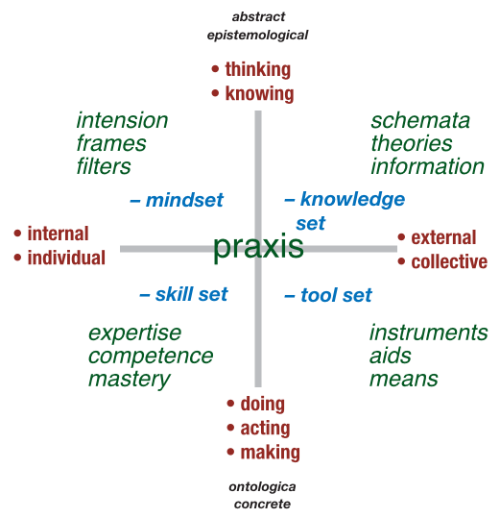

praxis

- Capacitation

Design expertise evolves over time (see scale in Appendix). This course focuses on initiating the development of capacities of design expertise at the level of competence and proficiency. These professional capacities are expected to continue to develop throughout your professional career therefore this course is a departure gate and not a final destination. The course is a catalyst for your further development of design expertise through design learning—i.e. preparation, application, and practice.

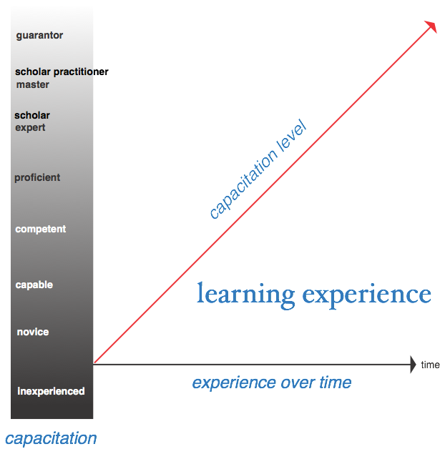

capacitation scale

- Design Abilities

The initiation and further development of your particular design abilities is the intended outcome for the course. The abilities listed below are inclusive and not exclusive of such abilities. The abilities are to be further developed over time beyond this class experience. There is no expected final end state in this development during or after class. As an advanced designer you are someone who is in the process of developing these abilities. Your progress is marked by a moving position along an analogue scale over time. Qualifications of individual designers need to be matched to the specifications of any particular design challenge. The assigned design project for this course prescribes the expected level of qualification for you in this design exercise.

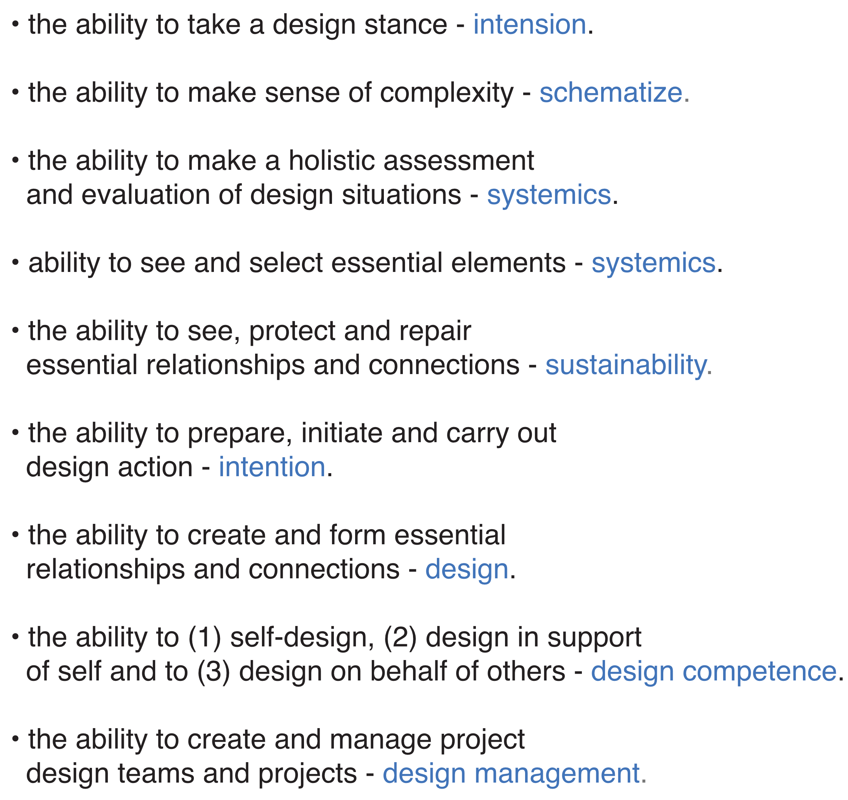

abilities

2. Evolving Capacities: Competencies & Proficiencies

This course focuses on initiating and supporting learning activities at the level of competence and proficiency on a capacitation scale. The expectation is that this will become an evolving, life-long developmental process expanding to include other levels of capacitation in your professional development.

- Competencies
• Professional and personal self-awareness and development.
• Able to integrate abstract, creative thinking with concrete action.
• Understands key theories, schema and methods in advanced design.
• Able to adopt complex, innovative decision-making processes.
• Adept at following given strategies of design inquiry.
• Understands and utilizes good design assessment approaches.
• Understands and utilizes good social science research.
• Utilizes systemic, creative and critical thinking skills.
• Make discernment of types of design approaches and innovation strategies.
• Make discernment of types of change and change strategies.
• Participates fully and effectively in functional design groups, teams and cohorts.

- Proficiencies
• Ability to see whole picture and take overview of complex situations.
• Awareness and modification of habits-of-mind.
• Ability to describe and explain complex design situations systemically.
• Ability to contract with design clients and surrogates.
• Determine desired change and concomitant scales of measurement.
• Determine agency for intentional change.
• Manage strategies for design inquiry for action and desired change.
• Use multiple perspectives for design assessment and change.
• Familiar with design inquiry methods and functions.
• Familiar with utility of basic modeling and simulation of social systems.
• Understand and utilize design leadership skills.
• Integrate ethical considerations in design judgments and decision-making.
• Take responsibility for continued professional development.

- Inquiry

This course treats design inquiry as a complex compound of designs of inquiry. Design inquiry is a rational, logical, creative, imaginative, aesthetic, and systemic approach to learning. Design inquiry is a compound of approaches to inquiry that, when integrated together, leads to prudent action. Description and explanation (i.e. good science) do not prescribe action but design inquiry does. Design inquiry is collaborative as well as personal.

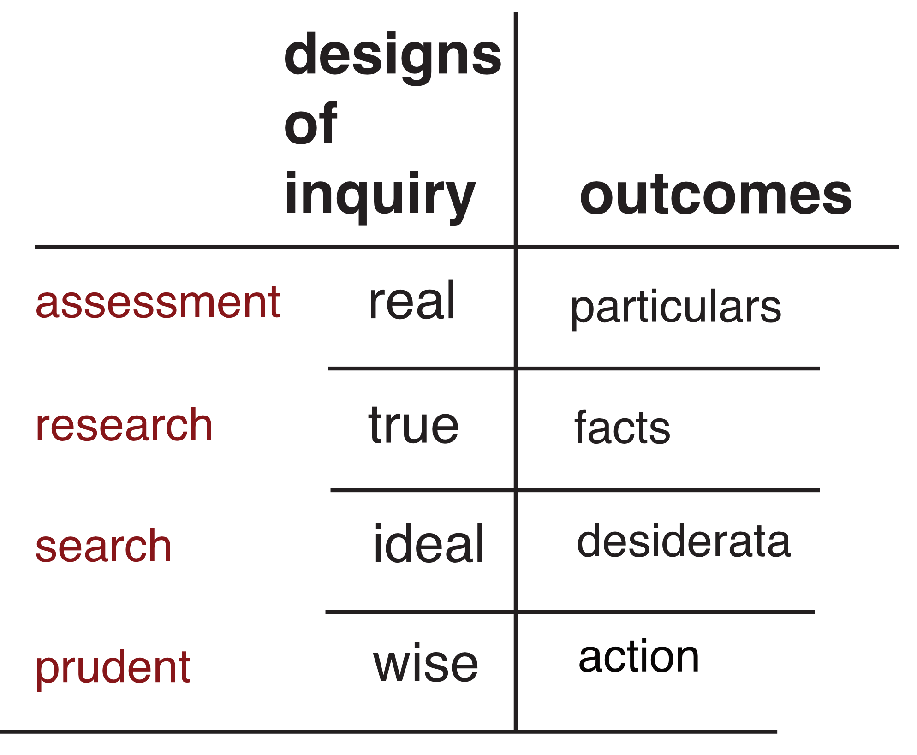

design inquiry

The modern world is complex, dynamic and interconnected requiring new approaches to inquiry. Domains of specialized perspectives and interests are systemically interrelated or interrelating such that issues of defense, safety and security are not separate from issues of well-being i.e. economic opportunity, health, social justice, equity, and education etc. Systemics is the means to describe and explain complex, ambiguous, indeterminate, and dynamic realities. Systemics is the logic of advanced design—the requisite approach for changing existing realities, through prudent action, into more desirable realities. You as a class participant will learn what is required to be a systemic designer.

You as a participant in this course will have had significant experience in the US Government dealing with the challenge of matching what is desired by the public and their governmental representatives with what is possible and what is prudent. This course is designed to assist you in making this challenge more reasonable and realistic for everyone involved.

- Class Deliverables: Design Project

The class design project is the design of an initiative to be proposed for the Naval Postgraduate School. The purpose of this initiative is to establish design competence at NPS. The design ‘client’ for this initiative is Prof. John Arquilla, Head of the Dept. of Defense Analysis at NPS

- Presentation Milestones

Demonstrations of learning for this course is evidenced through design exercises marked by the development and presentation of milestones marking the progress of an assigned design project terminating at the schematic design phase. Design documentation of design milestones will be presented throughout the quarter. The purpose of these design milestones is to demonstrate your ability to manage a design project using appropriate design skills, tools, knowledge and frames of mind. The milestone documentation counts for 80 percent of the class participants grade (20 percent for each milestone presentation).

Design Milestones:

- Design brief

- Design Assessment

- Design Evaluation

- Design Action

Documentation slides for class design milestones are due as assigned. Documentation for the final milestone is due June 3rd, 2016.

Class Participation

Class participation is a critical aspect of the learning process in this class. Unlike many other classes we are dealing in this course with a culture of inquiry where there are no right answers—only good or great ones. Through class discussion, you will practice assessing and strategizing how to formulate intentional action in complex, dynamic situations. As a class participant, you are expected to come to class in an open learning mode—willing to present your own ideas, while listening to and analyzing others’ ideas (peers, experts and other learning resources). Much, if not most, of the learning that occurs in this kind of course comes from the discussion that takes place during and outside of class with classmates. Be willing to be interactive in and outside of class. Take some risks and be supportive of the efforts of others. This participation accounts for 20 percent of your grade.

COURSE SCHEDULE

week 1 March 28 & 30

class 1 Orientation for Designing / Threads of Inquiry into Design

class 2 Preparation for Designing / Case Studies, Critiques

Reading: Additional resources as posted on class CLE site.

Questions for reflection:

- What are your expectations from the course?
- What is your understanding of design now?
- What are your assumptions and assertions about designing now?

week 2 April 4 & 6

class 3 Approaches to Designing, Assignment of Course Design Project

class 4 Design Capacitation & Pedagogy

Readings: resources as posted on class CLE site.

week 3 April 11 & 13

class 5 Design Processes & Methods

class 6 Case Studies as Experiential Learning

Readings: resources as posted on class CLE site.

week 4 April 18 & 20

class 7 Design Briefs

class 8 Design Inquiry for Action

Readings: resources as posted on class CLE site.
Week 5 April 25 & 27

Class 9 Design Challenge: Case

Class 10 Design Intension: Way Finding

Readings: Additional resources as posted on class CLE site.

Week 6 May 2 & 4

class 11 Design Teams & Design Cohorts

class 12 Milestone Presentations: Design Briefs

Readings: resources as posted on class CLE site.

Week 7 May 9 & 11

Class 13 Systemics

Class 14 Design Inquiry: Research, Assessment

Readings: resources as posted on class CLE site.

Week 8 May 16 & 18

Class 15 Presentation: Design Assessment

Class 16 Design Understanding: Critique and Appreciation

Reading: resources as posted on class CLE site

Week 9 May 23 & 25

Class 17 Presentation: Design Evaluation

Class 18 Design Intention: Purpose / Design Search

Reading: resources as posted on class CLE site

Week 10 June 1

Memorial Day Holiday

Class 19 Presentation: Desired Outcome

Readings: resources as posted on class CLE site.

Week 11 June 6 & 8

Class 20 Presentation: Proposed Action

Class 21 Presentation: Proposed Action / Debrief

Appendix

Dreyfus Capacitation Scale.
Dreyfus, Stuart E.; Dreyfus, Hubert L. (February 1980). A Five-Stage Model of the Mental Activities Involved in Directed Skill Acquisition (http://www.dtic.mil/cgi-bin/GetTRDoc?

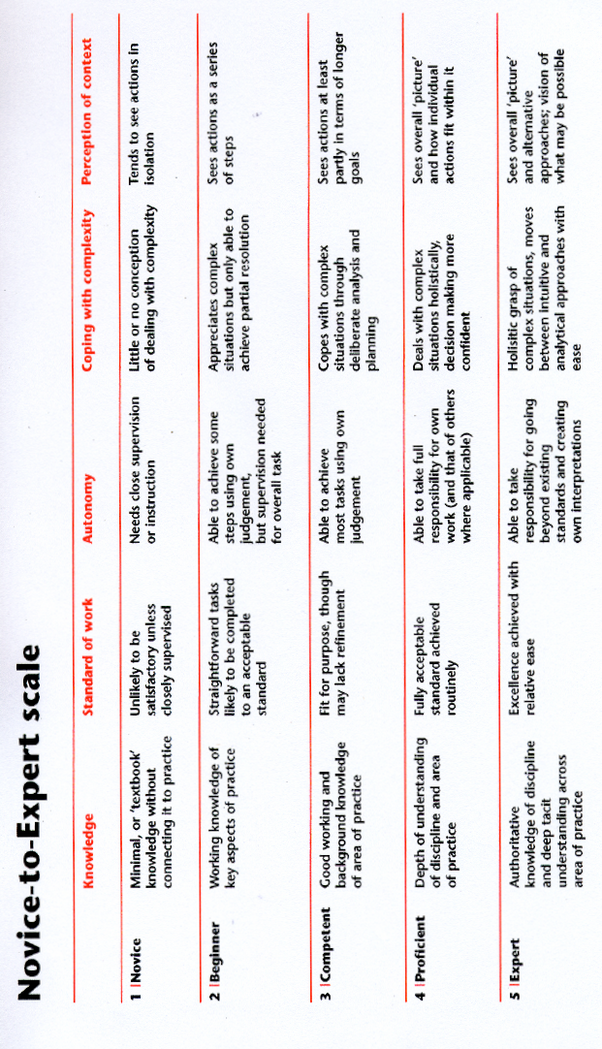

Mr. Y, A National Strategic Narrative

