You are cordially invited to watch the graduation ceremonies for the class of March 2017 on Friday, on the
Thirty-first day of March 2017 at
ten o’clock a.m. (PST), Web-cast live from King Hall,
Naval Postgraduate School Monterey, California

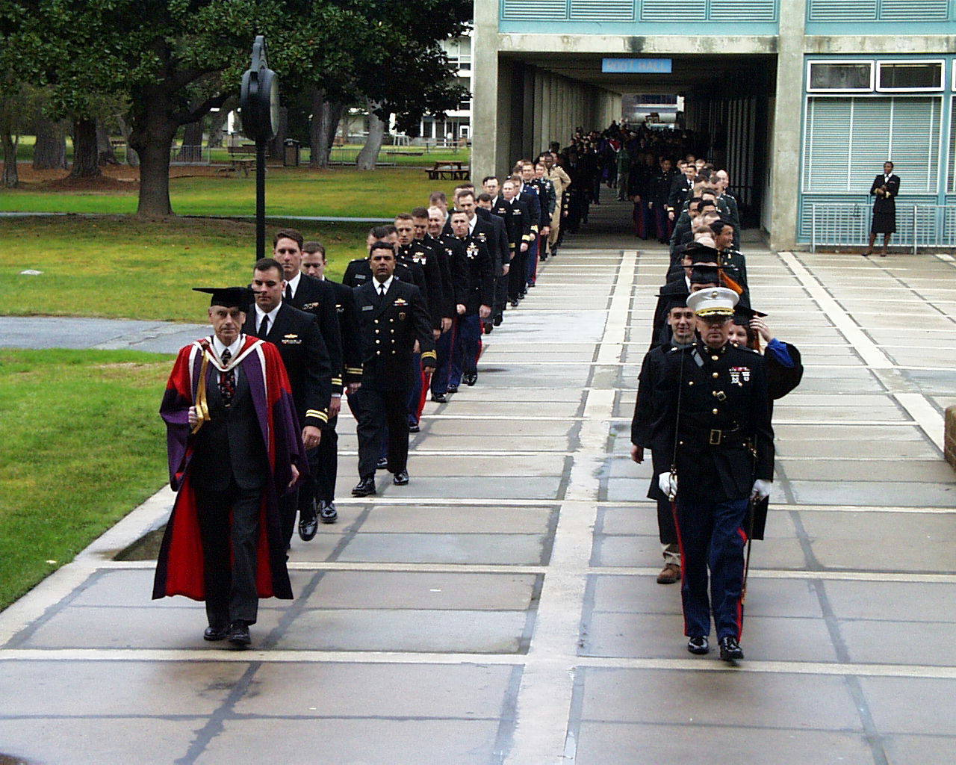
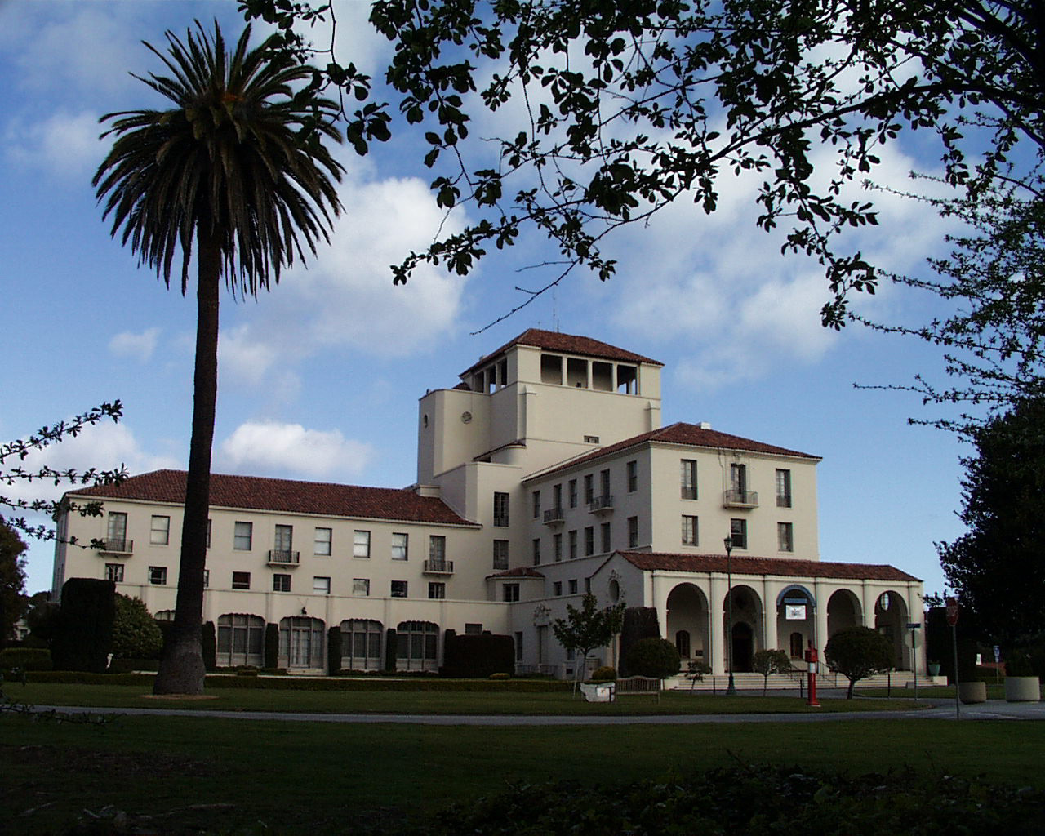

Watch by clicking
https://www.nps.edu/watchlive

