THESIS TEMPLATE SETUP
Do NOT use Word Online/Google Docs/other apps to work on your thesis.
Most of these are “lite” versions of the software and will corrupt your formatting.

Apply these settings the first time you work with the template on any computer. If you are working in a team, ensure all coauthors apply these settings as well.
Templates are available at nps.edu/web/thesisprocessing/templates-forms

Word 365 and 2019 for Windows (PC):
Turn Off AutoFormat MANDATORY
- From the File menu, select Options.
- From the left column, select Proofing.
- Click the AutoCorrect Options button.
  - Select the AutoFormat As You Type tab (left screen shot)
    - Under Replace as You Type, check all options.
    - Under Apply as You Type, uncheck all options.
    - Under Automatically as You Type, uncheck all options.
  - Select the AutoFormat tab (right screen shot).
    - Under Apply, uncheck all options. Click OK.
    - Under Replace, check all options. Click OK.

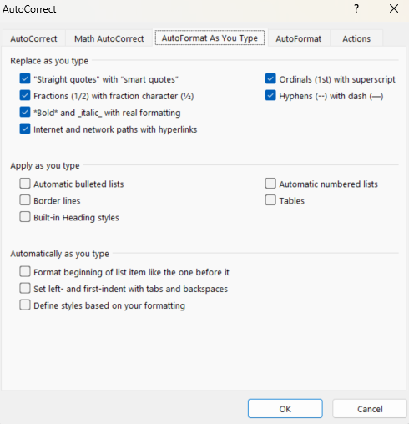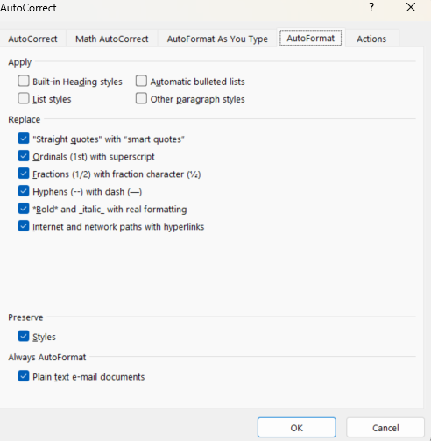
Turn Off Keep Track of Formatting MANDATORY
- Back on the Options menu, select Advanced from the left menu.
- Ensure Keep track of formatting is unchecked.
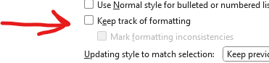
Display the Styles List
- Select the Home tab in the Ribbon.
- In the Styles panel, select the small arrow in the bottom-right corner of the panel.
- The template “Styles” list will be displayed on the right side of the document.
- Choose a style from this list to apply that style to an element of the document.

Word 2016 and earlier: Not supported

Word for Mac:
Turn Off Auto Formatting Options MANDATORY
- From the Word menu, select Preferences.
- Select the AutoCorrect icon.
- Select the AutoFormat as You Type tab.
- Uncheck all options under Replace as you type.
- Check all options under Automatically as you type (middle section of left screen shot)
- Uncheck all options under Automatically as You Type (bottom section of left screen shot)

Turn Off Keep Track of Formatting MANDATORY
- From the Word menu, select Preferences.
- Select the Edit icon.
- Under Editing Options, uncheck Keep track of formatting (right screen shot)

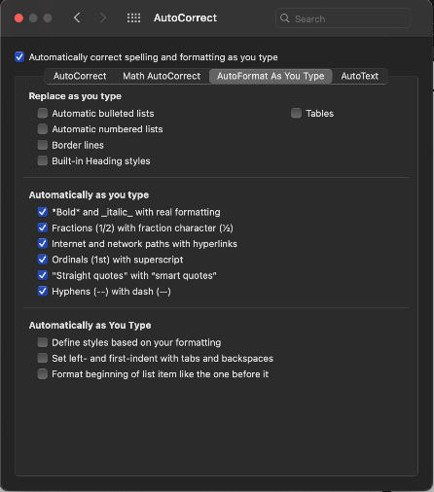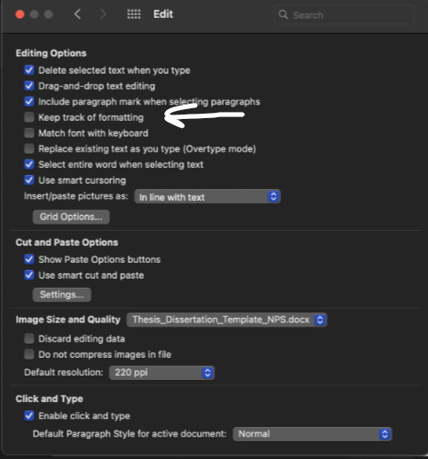

Display the Style List
- The template styles are located at the top, in the Home tab, in the Styles pane.
  - Click Styles Pane to display the styles
  - Under List, select Recommended.
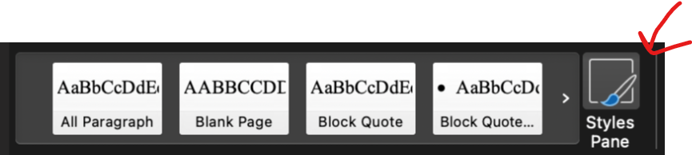

File-Naming Convention
Use the below file name exactly (heed capitalization) every time you submit a draft to the TPO.
This ensures the newest file is always displayed on your file-sharing site. Older versions of documents with the same file name are maintained in version control history, accessible by clicking the three dots that appear to the right of the file name.

YYMon_LastName_FirstName
YY = graduation year
Mon = graduation month
24Mar_LastName_FirstName

More than one author? Use:
YYMon_LastName1_LastName2_LastName3
match order in Python thesis dashboard
24Mar_Smith_Jones_Young

24Mar_Anderson et al
SE capstone? Use:
YYMon_FirstAuthorLastName et al
last name of first author (by alphabet) et al

THIS PAGE INTENTIONALLY LEFT BLANK

