"You are Brave, Brainy and Beautiful"
Ms Latina World 2010 Valencia De La Vega to speak at two Salinas, CA community events during the weekend of May 18, 2012.
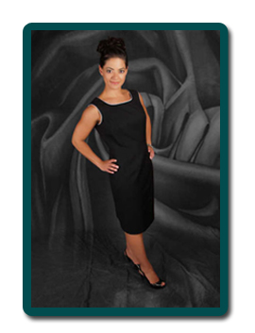
The Cebrowski Institute has been working for the past 5 years with Hartnell Community College to incentive Salinas youth to pursue Science, Technology, Engineering and Math (STEM) degrees through the highly successful “Community College Catalyst” (3C) internship program. Hartnell students are matched with an NPS researcher for 8-week internships during the summer. The success rate for these students is unparalleled; 100% of the 3C alum are pursuing a STEM degree or have already graduated from a 4 year university with a STEM degree.
STEM disciplines are not a traditional pathway for Hispanic youth. Exposing families to Hispanic STEM role models as well as offering opportunities in STEM research is important to address the US need for future scientists and engineers. Ms De La Vega fits this role well.
Ms De La Vega earned a nuclear engineer major from West Point. Shortly after 9/11, her Army unit was the third group into Afghanistan following the Marine Corps Force Reconnaissance and Army Special Forces units After leaving the Army, she earned a Masters Degree in Business Administration in Finance. She is currently the Tooling Technical Program Manager at Intel where she and her group help design tools to test Intel products.
In 2009, she was "fed up with the hyper promotion of tissue-thin beauty queens" and entered the Ms. Latina World Beauty Pageant. She wanted young women to understand that “as a women, being an engineer and being smart did not mean that I compromised my femininity. You can be both beautiful and intelligent.” And we add brave to the list!
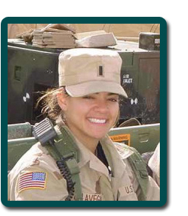
We invited Ms De La Vega to come to the Salinas Valley the weekend of May 18 for two public events:
Friday evening, May 18 she will address the Salinas community in the Steinbeck Hall at Hartnell College. A local youth folkloric dance group will kick off the evening at 6:30 p.m.
On Saturday afternoon, May 19 from 11:00 a.m. - 3:00 p.m. she will be at the Hartnell College Family Science Day, held on the main Hartnell Campus
Hope to see you there!
Click here for Ms Latina Worldofficial website

